Summer 2018 Conference
30th June 2018
Institute of Education
Active Approaches to Teaching Text

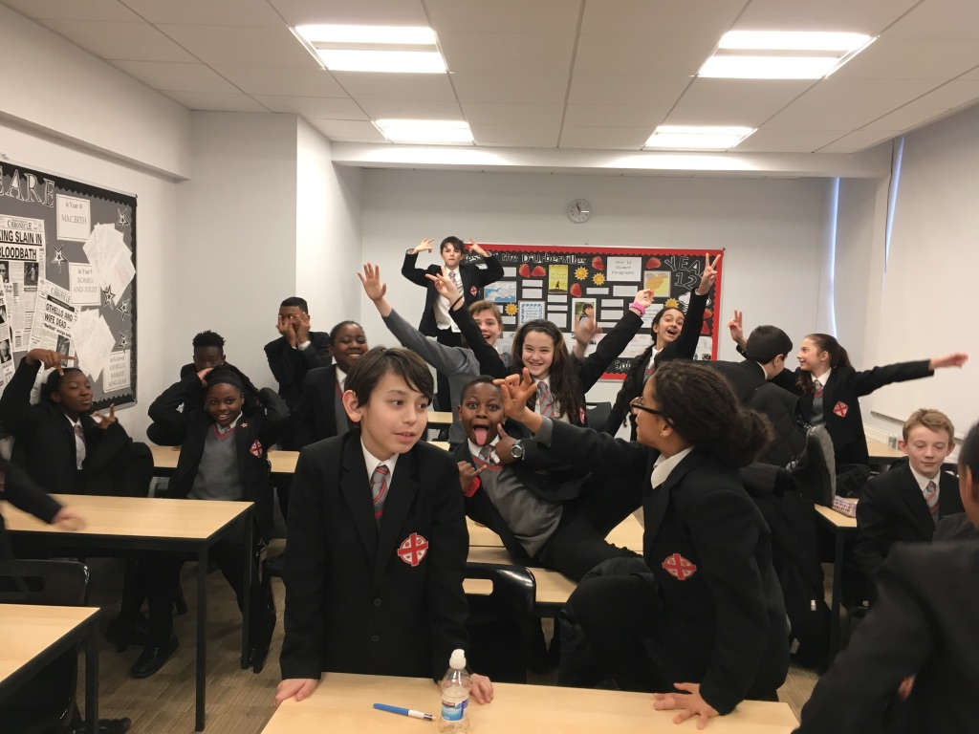
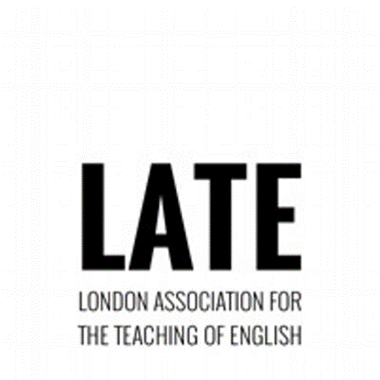

Conference Programme
9.30-10.00am Coffee and Registration

10.00- 11. 00 Key Note 1 Maggie Pitfield Goldsmiths Universityof London

11.00-12.15 Workshops

12.15-1.15 Key Note 2 Laurie Bolger Bang Said The Gun

1.15 Lunch (buffet provided) and a video presentation of students’ creative responses to literature from Alexadra Park School

Key Note 1
Maggie Pitfield
Goldsmith’s University of London

Maggie Pitfield’s talk will consider the role of drama in teaching English. Her research with English teachers and learners in secondary schools asks the question: What contribution does drama make to teaching and learning in English? Maggie will share some of her findings and will focus on ways in which drama can be employed actively and creatively in the teaching of reading. She is keen that English teachers strongly advocate for drama as a key part of the English curriculum and will suggest ways in which English teachers might overcome some of the constraints they face in including drama as an integral part of their teaching. Maggie taught English and Drama for 24 years in London secondary schools before moving into higher education, first as a PGCE English tutor, then as Head of the MA in Children’s Literature. Currently she is Head of the Department of Educational Studies at Goldsmiths.

Key Note 2
Laurie Bolger
Bang Said the Gun
London Laureate Laurie Bolger has hosted venues such as The Royal Albert Hall, St Paul’s Cathedral and Southbank Centre London as well as being commissioned by BBC Radio 1, The Verb and 1Xtra. Her debut poetry collection Box Rooms was released by Burning Eye Books, showing that poetry can be your friend.
www.lauriebolger.com

‘The poet in residence of my heart.’ ‘Porky the Poet’ Phill Jupitus

‘If I could jump into Laurie’s poems I would. I imagine it’d be lovely and warm in there.’ Hollie McNish

‘Brilliant.’ Geoff at the Bar

Links
Slippers
https://www.youtube.com/ watch?v=tELqSmt8E9M&t=1s
Public House
https://www.youtube.com/watch?v=v2pZtFPzdUk
Show reel
https://www.youtube.com/watch?v=Upxm7szKhi8

Laurie will be sharing some of her work as well as speaking about her own unique path from studying poetry at GCSE to becoming a full-time writer. Laurie will also discuss her own approaches to teaching creative writing in the classroom.

Workshops
You will be able to choose one workshop on the day.

Workshop 1
Exploring Macbeth with The National Theatre
Jane Ball and Ruth Johnson
Drawing on rehearsal room processes, this workshop will introduce practical strategies for exploring the play with your students. You’ll go away with a range of exercises exploring language, character, themes and story-telling that can be used in the classroom. The workshop will draw on the National Theatre’s two recent productions of Macbeth and will be led by Ruth Johnson, Assistant Director for the schools touring production with Jane Ball, Secondary & FE Programme Manager for NT Learning.

Ruth Johnson is an experienced actor, director, facilitator and former English and Drama teacher. She has worked extensively on learning and participation projects and productions for companies including New Writing North, Northern Stage, Open Clasp and Unfolding Theatre. For the National Theatre she was Assistant Director for the schools tour of Macbeth in 2017.

Jane Ball manages the extensive Secondary and FE Programme for National Theatre Learning, including New Views, the theatre’s nationwide playwriting programme and competition for 14-19 year-olds. She oversees the development of learning resources and publications and has a particular interest in the teaching of plays in the English Classroom.

Workshop 2
What the Dickens: active approaches to 19th century texts
This workshop will take the form of a panel of teachers who all take creative and / or active approaches to teaching 19th century texts. Each panellist will present the resources and approaches they take and will provide you with ideas and resources to take away. Once the presenters have finished there will be time for a discussion and Q&A amongst workshop participants.
Kate Bomford, English Teacher at Woodhouse Sixth Form College
This presentation takes as its starting-point the idea that not all forms of writing that support essay writing look like essay writing. Focussing on my experience of teaching Frankenstein as part of an A-Level English Literature course this year, it explores the value of using simple, structured, creative writing tasks as a means of developing students’ critical responses to a complex literary text. It considers some examples of creative writing produced in the classroom, alongside students’ own accounts of how and why they found this kind of writing valuable (or not!). It concludes with a brief overview of some of the questions this type of task raises about the ways in which we assess students’ responses to literary texts, both in the classroom and in the context of public examinations.
Suzanne Feeley, English teacher Twyford C of E High school
Suzanne has been a teacher for over 20 years and currently works in a school in West London where she teaches A Christmas Carol. Her presentation will show some of the ways she has found to engage students in so called ‘bottom sets’ with one of Dickens’ most taught tales and ensure that it is enjoyable and accessible to everyone. The presentation will include some of the resources she has created and the thought process behind them as well as some discussion of how her students have found using them and the 19th century element of the GCSE course generally.
Nick Bentley, English Teacher in London
In my presentation, I will consider the benefits of using active approaches in exploring texts, especially the inclusive nature of such approaches. Drawing on my work with drama, English and literacy classes at my all-girls secondary comprehensive school in East London, I will look at the ways literary texts can be unlocked by bringing them to life in different ways. Focusing on the ways in which drama can be used as a learning medium - including teacher-in-role, images, choral work and hot seating - I will look at the ways different literary and non-literary texts can be unpacked and made accessible, meaningful and enjoyable.
Stuart Scott, Collaborative Learning
Stuart will be introducing a mix of role play, hot seating and other interactive activities around Oliver Twist, Great Expectations and Bleak House which will all be available on line after the session on:
www.collaborativelearning.org/literaturefiction.html
Workshop 3
Dr Jekyll and Mr Hyde: Drama and Film-making
Theo Bryer, Lecturer in English and Drama, Institute of Education UCL
This practical workshop involves drama and iPad filmmaking to explore aspects of Stevenson’s text. We will start by mapping the incidents of the narrative around London, through a dramatic approach. You will shoot and edit a short film set in an imagined location and learn how to use iMovie in the process. The activities are suitable for KS3 or KS4 students who are studying the novella and can be adapted for other texts – to encourage students to develop their own readings and insights in memorable ways.

Workshop 4
Claudius’ court is a stage: a place of performance and pretence- active approaches to Hamlet at A-Level
Anne Turvey, Lecturer in Education at the Institute of Education and Myfanwy Marshall, English teacher at Twyford C of E High school in Acton
Elsinore: the day of the marriage of Claudius and Gertrude. Claudius wants to commemorate this day. Portrait painters and miniaturists at the Tudor court are so yesterday: they have been overtaken by a new breed – celebrity photographers. Claudius has engaged the very best and he has thought carefully about how he wants to present the royal couple and the court in a photograph. His instructions are precise.
This activity is one from a workshop that Jane Coles, Theo Bryer and Anne Turvey ran with a group of PGCE students at City and Islington Sixth Form College. Our brief was to address a specific examination question from the AQA specs: ‘Claudius’ court is a stage: a place of performance and pretence’. As well as ‘preparing for the examination’, we drew on active approaches to literature that are familiar to English teachers working with pupils at Key Stages 3 and 4 but perhaps less common at KS5. We want to share some of the ideas – and the results – from this day working with sixth form students and how we tried to integrate the ‘critical and the creative’ dimensions of studying Hamlet at A level.

Stay in Touch
Twitter & Instagram @Londonlateteachers
Facebook @LondonEnglishTeachers

Join Our Mailing List
Email:
J.Yandell@ucl.ac.uk
m.marshall.14@ucl.ac.uk
shah.mehrunissa@gmail.com

